What is the Difference between Sequential and Combinational Logic Circuits?



*Counter:*

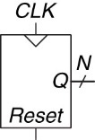

Flip-Flop –

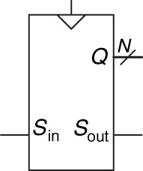*Shift Register:*



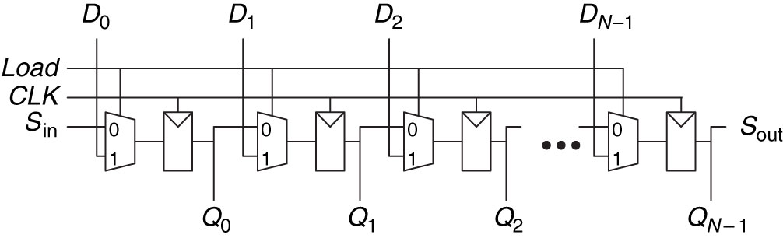

What is the difference between a Shifter and a Shift Register?



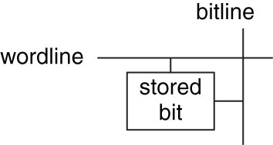Memory

* **Address – Indicates which ________ of ________ is read/written (location) _____ (___-Bits)**
* **Data – ________ read/written (___-Bits)**
* **Word – ________ of a ________ of ________ (___-Bits)**
* **Depth – Number of ________**
* **Width – Number of ________**
* **Wordline – ________ based on ________ to activate bit cells in a ________**
* **Bitline – kept at ____; when ___________ is activated, driven to 1 or 0 by bit cell to ________**
  + **When written , drives bit cell high or low**
* **Port – Gives ________ /________ access to the ________; multi-ported can read/write several __________ at the same time**

Address –

Data –

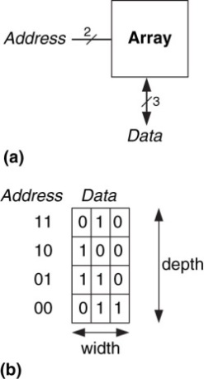Word –

Depth -

Width –

Wordline –

Bitline –

Port –

**RAM – Random Access Memory**

* + - **Delay _______ for all _______, vs sequential (e.g. type)**
    - **_______ – _______ its data when the power is lost**

**ROM – Read Only Memory**

* + - **Also __________ accessed**
    - **Many can be _______ now**
    - **_______ -_______**

**Types of memory:**

**RAM – ________ _______ Memory**

**ROM – ________ _______ Memory**

|  |  |  |  |  |  |  |  |  |  |  |  |  |  |
| --- | --- | --- | --- | --- | --- | --- | --- | --- | --- | --- | --- | --- | --- |
| ***Types of RAM:***  **DRAM –**  **DRAM – Dynamic RAM**   * + **Bit stored as ________ or ________ of ________ on a capacitor**   + **Reading ________ data; must be rewritten**   + **Must be ________ every few miliseconds due to leaking charge**   **SRAM –**  **SRAM – Static RAM**   * + **Does not need ___________**   + **Bit stored in ________ ________ inverters**   + **Inverters can restore value if ________ ________** | ***Types of DRAM:***  **SDRAM –**  **SDRAM – _____________ DRAM**   * + - **Uses ____________ memory access**   **DDR SDRAM – ________ _____ _____ SDRAM**   * + - **Uses _____ and _____ edge to access data**   **DDR SDRAM –**   |  |  |  | | --- | --- | --- | | **Memory Type** | **Transistors per bit cell** | **Latency** | |  |  |  | |  |  |  | |  |  |  | |

**Register file -**

**Register File – ________ of registers that ________ temporary ________**

* + **Often consists of small ______________ ________**

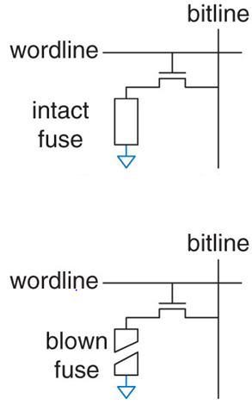*Types of ROM:*

**PROM – __________ ________ ________ Memory– Provides a way to connect transistor with _______**

**PROM**

**Fuse Programmable ROM**

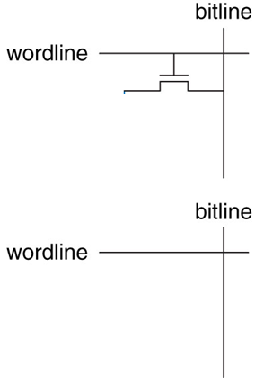PROM –

**________ ______________ ROM – _____ _____ = 1, cannot be rewritten**

Fuse-programmable ROM –

**EPROM – ____________ PROM**

* + **High voltage to ________**
  + **_____ ________ to erase**

EPROM –

**EEPROM – ____________ EPROM**

* + **Bit cells ___________ erased**
  + **Erased without UV light with extra circuitry**

EEPROM –

**Flash – ________ ________ ________**

* + **Cheaper because less ________ circuitry**

Flash –

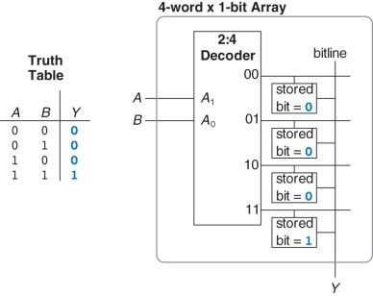Logic using memory arrays:

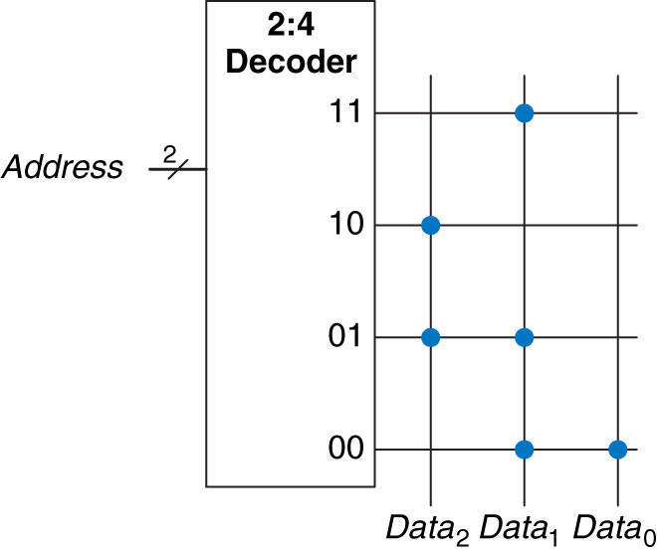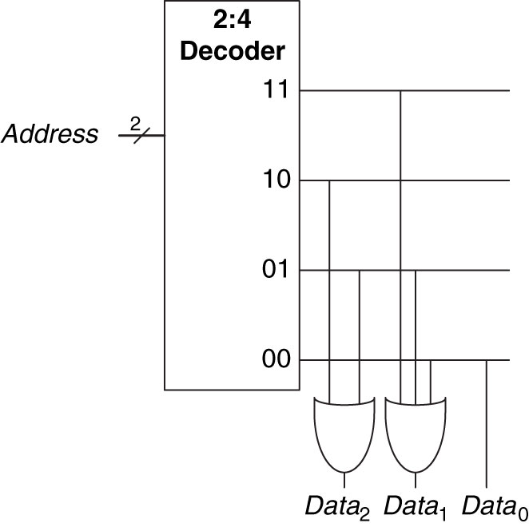3 ROM Dot Notation with and without gates: